A1206-Asia-India-Tamil Nadu-Bas-Relief-Architectural-ca 1950 CE

**Case no.: 3**

**Accession Number: A1206**

**Formal Label:** India-Tamil Nadu-Bas-Relief-Architectural-ca 1950 CE

**Display Description:**

Mid-20th century, carved wood panel from a processional chariot with depictions of Siva, with his consort Parvati on one side and a bearded sage, or rishi on the other side. He may be identified as the author, Tamil savant Thiruvalluvar (4th century BCE to 7th century CE based on the traditional accounts and the linguistic analyses of his writings.) He authored the Thirukkural a collection of couplets on ethics, political and encyclopedic formulae for ethical living.

**LC Classification:** NK1048.T36

**Date or Time Horizon:** 1950 CE

**Geographical Area:** Tamil Naadu

**Map, GPS coordinates:** Thirunayanarkurichi, a village in present-day [Kanyakumari district](https://en.wikipedia.org/wiki/Kanyakumari_district) may be the birthplace of Thiruvalluvar based on a claim of an old [Kani](https://en.wikipedia.org/wiki/Kani_tribe) tribal leader who related in 2005 that Thiruvalluvar was a king who ruled the "Valluvanadu" territory in the hilly tracts of the Kanyakumari district**,** [8.078°N 77.541°E](https://tools.wmflabs.org/geohack/geohack.php?pagename=Kanyakumari_district&params=8.078_N_77.541_E_type:city(1870374)_region:IN-TN) (

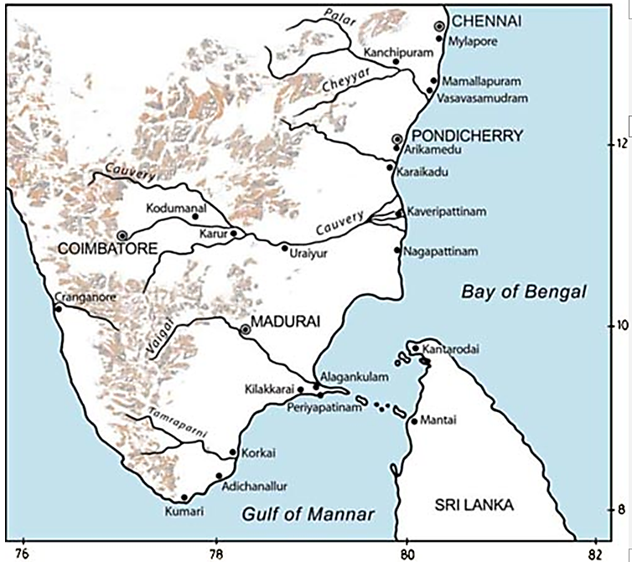

Fig. Key Tamil Nadu archaeological sites from (Kalidos 1988).

**Cultural Affiliation:** Tamil Nadu

**Medium:** wood

**Dimensions:** H 33 cm, 11 15/16 in, W 18 cm, 7.5 in

**Weight:**

**Condition: original**

**Provenance:** Tamil Nadu, Ekapadamurti Ganapati Car.

**Discussion:**

**The relative proportions of the represented deities in Tamil Nadu have the highest percentage in Temple cars (chariots) for scenes with Siva (Kalidos 1988).**

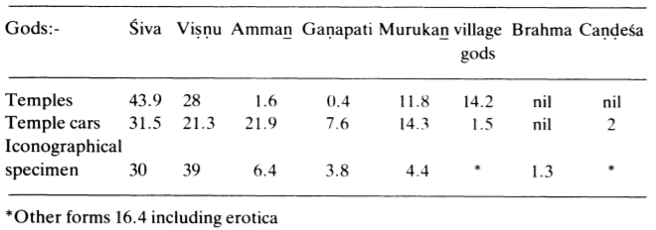

**“**Siva, first in regard to temples and cars, occupies a secondary place from the iconographical aspect. Amman, insignificant in respect of temples, is second in respect of cars and occupies the third place in respect of iconography. Vishnu occupies the first place in iconography though he occupies secondary and tertiary places in other respects. The reason for this is that he is represented in cars of all the gods. This is mainly because Vishnu as Krishna and Sri Rama is the hero of the two great national epics -- the Mahabharata and Ramayana -- which have deep roots in élite and folk culture, and no iconographical museum in India could neglect him” (Kalidos 1988).

**References:**

Anon. 2005. ["Research team claims to have found Thiruvalluvar's kingdom,"](http://zeenews.india.com/home/research-team-claims-to-have-found-thiruvalluvars-kingdom_213930.html).*Zee News*, 26 April.

Kalidos, Raju. 1988. “The Wood Carvings of Tamil Nadu: An Iconographical Survey,”   
*Journal of the Royal Asiatic Society of Great Britain and Ireland*, 98-12

 Date 20th century